**BỘ GIÁO DỤC VÀ ĐÀO TẠO**

**ĐẠI HỌC CÔNG NGHỆ TP.HCM**

**BÁO CÁO THỰC HÀNH XỬ LÝ ẢNH TRONG Y TẾ**

SV : Trần Trọng Tấn

Lớp : 18DYSA1

www.hutech.edu.vn

**BÁO CÁO THỰC HÀNH TIN HỌC KỸ THUẬT**

Ấn bản 2019

MỤC LỤC

MỤC LỤC 1

BÀI 1: CƠ SỞ VỀ XỬ LÝ ẢNH 2

BÀI 2: XỬ LÝ ẢNH NÂNG CAO 10

# CƠ SỞ VỀ XỬ LÝ ẢNH

**Bài 1.1** Đọc ảnh:

1. Code

table = imread(['image1.jpg']);

imshow(table)

1. Kết quả

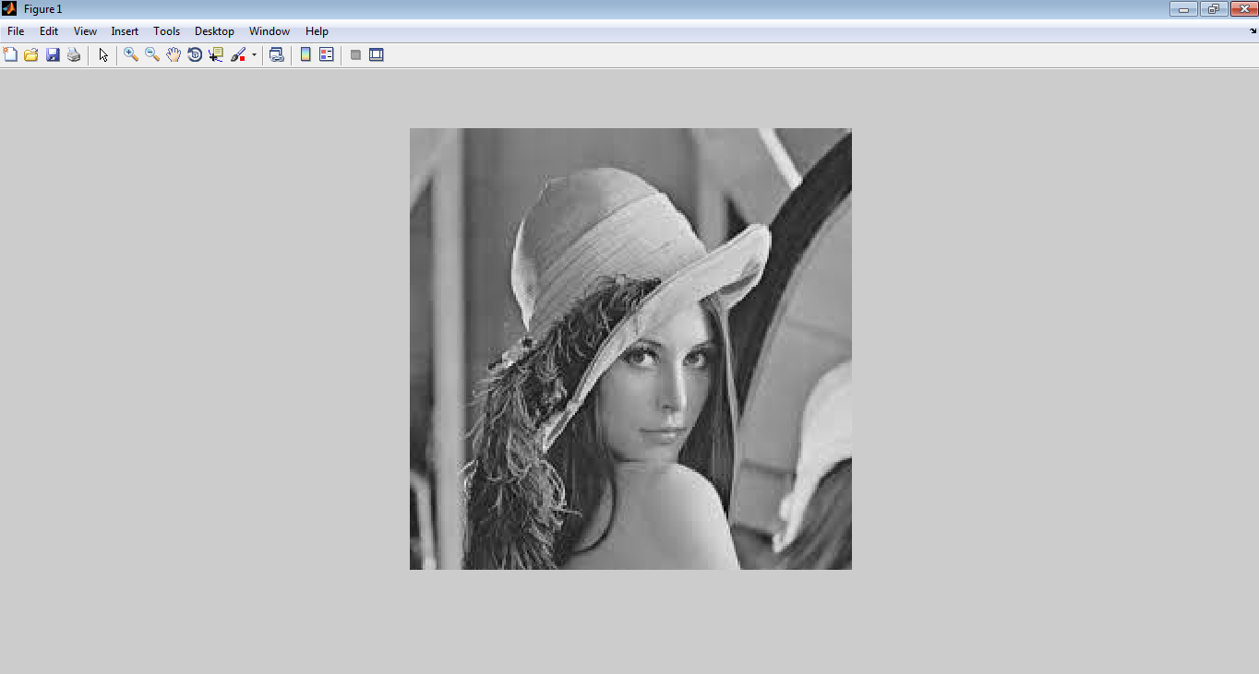

**Bài 1.2**

1. Code

Whos

1. Kết quả

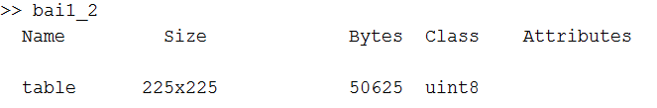

**Bài 1.3**

1. Code

figure, imhist(table)

table2=histeq(table);

figure, imshow(table2)

figure, imhist(table2)

1. Kết quả

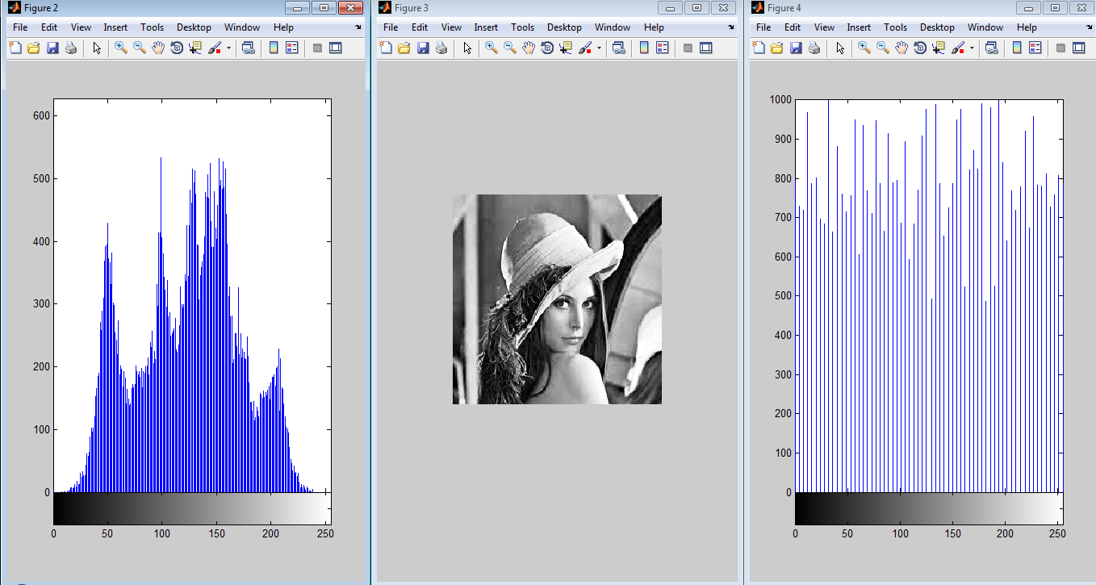

**Bài 1.4**

1. Code

imwrite(table2, 'table2.png');

1. Kết quả



**Bài 1.5**

1. Code

imfinfo('table2.png')

1. Kết quả

ans =

Filename: 'C:\Users\Administrator\Documents\MATLAB\table2.png'

FileModDate: '12-Dec-2020 14:46:30'

FileSize: 24512

Format: 'png'

FormatVersion: []

Width: 225

Height: 225

BitDepth: 8

ColorType: 'grayscale'

FormatSignature: [137 80 78 71 13 10 26 10]

Colormap: []

Histogram: []

InterlaceType: 'none'

Transparency: 'none'

SimpleTransparencyData: []

BackgroundColor: []

RenderingIntent: []

Chromaticities: []

Gamma: []

XResolution: []

YResolution: []

ResolutionUnit: []

XOffset: []

YOffset: []

OffsetUnit: []

SignificantBits: []

ImageModTime: '12 Dec 2020 07:46:30 +0000'

Title: []

Author: []

Description: []

Copyright: []

CreationTime: []

Software: []

Disclaimer: []

Warning: []

Source: []

Comment: []

OtherText: []

# XỬ LÝ ẢNH NÂNG CAO

**Bài 2.1**

1. Code

clear, close all

i=imread('santa.jpg');

imshow(i)

1. Kết quả

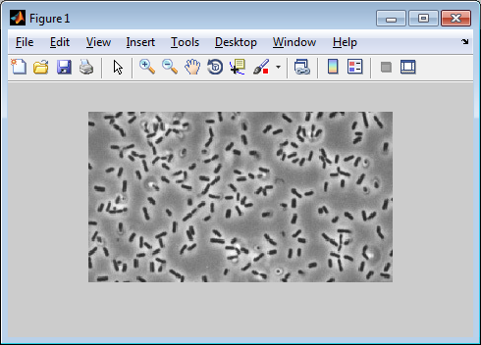

**Bài 2.2**

a.Code

bg=imopen(i,strel('disk',15));

imshow(bg)

b.Kết quả

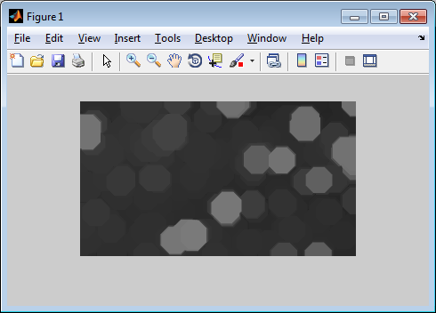

**Bài 2.3**

a.Code

figure, surf(double(bg(1:8:end, 1:8:end))),zlim([0 255]);

set(gca, 'ydir', 'reverse');

b.Kết quả

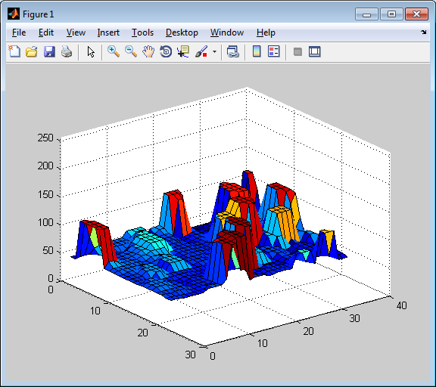

**Bài 2.4**

a.Code

i2=imsubtract(i,bg);

figure, imshow(i2)

b.Kết quả

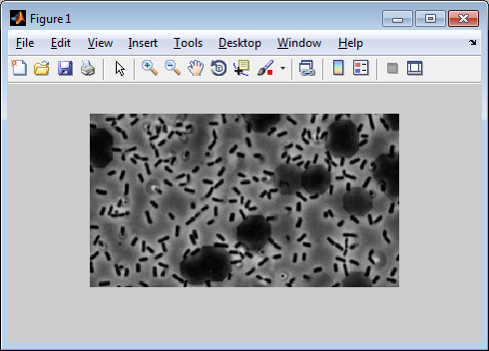

**Bài 2.5**

a.Code

i3= imadjust(i2, stretchlim(i2), [0 1]);

figure, imshow(i3)

b.Kết quả

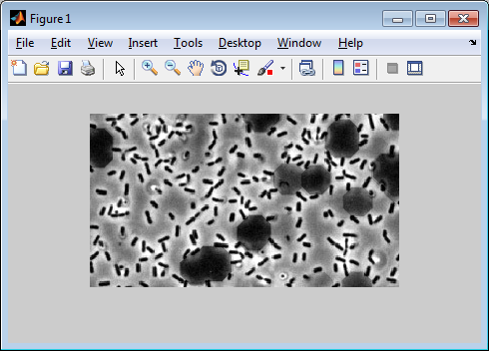

**Bài 2.6**

a.Code

lv=graythresh(i3);

bw=im2bw(i3,lv);

figure, imshow(bw)

b.Kết quả

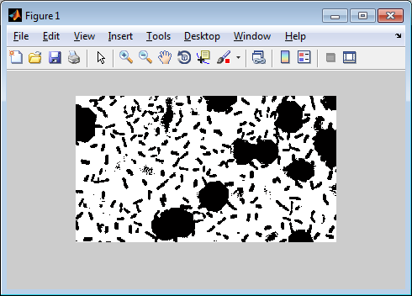

**Bài 2.7**

a.Code

[labeled,numObjects]=bwlabel(bw,4);

numObjects

b.Kết quả

numObjects =

24

**Bài 2.8**

a.Code

grain=imcrop(labeled)

RGB_label=label2rgb(labeled, @spring,'c','shuffle');

imshow(RGB_label);

b.Kết quả

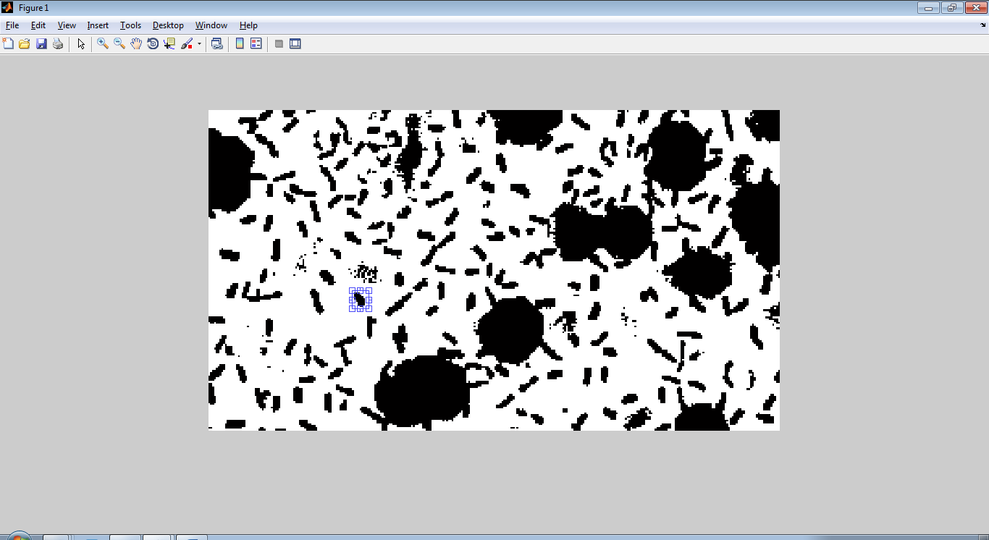

**grain =**

**1 1 1 1 1 1 1 1 1**

**1 0 0 0 1 1 1 1 1**

**1 0 0 0 0 1 1 1 1**

**1 0 0 0 0 0 1 1 1**

**1 0 0 0 0 0 0 1 1**

**1 1 0 0 0 0 0 1 1**

**1 1 1 0 0 0 0 1 1**

**1 1 1 0 0 0 0 1 1**

**1 1 1 1 0 0 1 1 1**

**1 1 1 1 1 1 1 1 1**

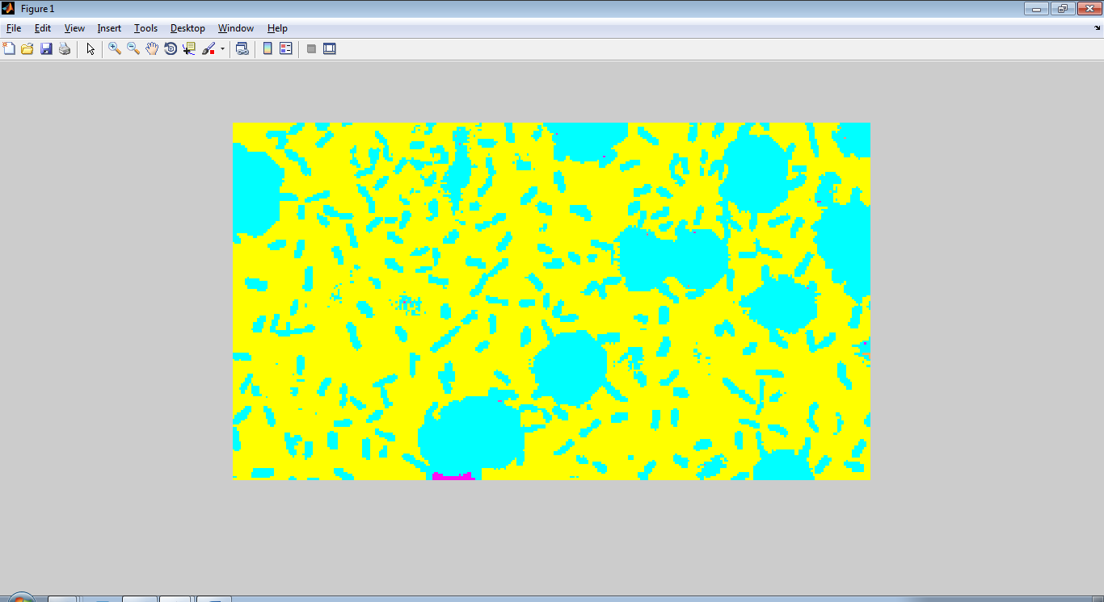

**Bài 2.9**

a.Code

graindata=regionprops(labeled,'basic')

graindata(21).Area

graindata(21).BoundingBox, graindata(21).Centroid

allgrains=[graindata.Area];

whos allgrains

b.Kết quả

graindata =

24x1 struct array with fields:

Area

Centroid

BoundingBox

ans =

1

ans =

Columns 1 through 3

295.5000 2.5000 1.0000

Column 4

1.0000

ans =

296 3

Name Size Bytes Class Attributes

allgrains 1x24 192 double

**Bài 2.10**

a.Code

max(allgrains)

biggrain=find(allgrains==36971)

mean(allgrains)

hist(allgrains,20)

b.Kết quả

ans =

36971

biggrain =

1

ans =

1.5439e+03

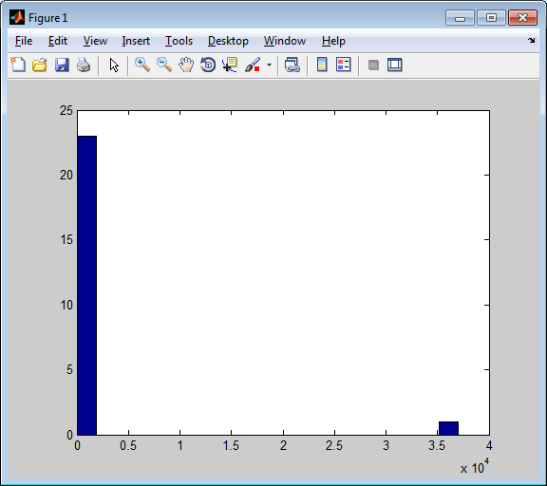

# XỬ LÝ ẢNH Y TẾ - PHẦN 1

Phần 1, cung cấp các kiến thức:

(1) load MRI data into MATLAB

(2) display three anatomically oriented slices of the head MRI

(3) apply a binary mask to extract the brain tissue

(4) display three brain slices

(5) implement an edge detector to grab and display all edges of a slice

Nhiệm vụ của SV, thực hiện theo các bước hướng dẫn, ghi nhận báo cáo kết quả và nhận xét, sau đó làm các bài tập theo yêu cầu ở cuối phần 1

% load mat file containing the original mri

load raw_mri

% see what's in memory

whos

% create a subplot window

subplot(2,2,1)

% grab the coronal slice corresponding to y=128 and store it in a new

% variable

coronal_slice = mri(:,128,:);

% NOTE: colon operator denotes "all" elements in the given dimension

% NOTE: semicolon after line suppresses output

% get the size of the slice

size(coronal_slice)

% NOTE: no semicolon as we want to display the current size of the variable

% "coronal_slice"

% remove "singleton" dimension

coronal_slice = squeeze(coronal_slice);

% observe the size of the array after squeezing

size(coronal_slice)

% NOTE: "coronal_slice" is now a 2-dimensional array

% display slice

imagesc(coronal_slice);

% NOTE: intensity of each pixel corresponds to tissue type

% change to a grayscale colormap

colormap(gray)

% add a title to our subplot

title('Coronal Slice')

% display the coronal slice right side up

% create a second panel

subplot(2,2,2)

% display the transposed matrix

imagesc(coronal_slice');

% NOTE: in MATLAB, the prime operator ' denotes matrix transposition

% make the axes Cartesian

axis xy

% insert new title

title('Coronal Slice Right Side Up')

% display the sagittal slice

subplot(2,2,3)

% grab a slice corresponding to the y-z plane

sagittal_slice = mri(128,:,:);

sagittal_slice = squeeze(sagittal_slice);

imagesc(sagittal_slice');

axis xy

title('Sagittal Slice')

% display the axial slice

subplot(2,2,4)

% grab a slice corresponding to the x-y plane

axial_slice = mri(:,:,95);

axial_slice = squeeze(axial_slice);

imagesc(axial_slice');

axis xy

title('Axial Slice')

%%

% load mat file containing our data: mask of the brain

load brain_mask

% display the contents of memory

whos

% NOTE: the mask is stored in a variable called "m"

% get the size of the mask m

size(m)

% get the type of data contained in the "m" variable

class(m)

% get the type of data contained in the "mri" variable

class(mri)

% since the data types don't match up, we must convert one of them to match

% the other if we want to do any processing

% convert "mri" to a floating-point array (as opposed to integer data)

mri_new = double(mri);

% compare the size of "mri_new" with that of "mri"

whos

% now observe the type of data in "mri_new"

class(mri_new)

% apply the mask to the mri image

masked_mri = mri_new.*m;

% NOTE: .* denotes element-by-element multiplication, which is not the same

% as matrix multiplication

% display three brain slices

% create a new figure window

figure

subplot(2,2,1)

masked_coronal_slice = masked_mri(:,128,:);

masked_coronal_slice = squeeze(masked_coronal_slice);

imagesc(masked_coronal_slice');

axis xy

colormap(gray)

title('Masked Coronal Slice')

% display the sagittal slice

subplot(2,2,2)

masked_sagittal_slice = masked_mri(128,:,:);

masked_sagittal_slice = squeeze(masked_sagittal_slice);

imagesc(masked_sagittal_slice');

axis xy

colormap(gray)

title('Masked Sagittal Slice')

% display the axial slice

subplot(2,2,3)

masked_axial_slice = masked_mri(:,:,95);

masked_axial_slice = squeeze(masked_axial_slice);

imagesc(masked_axial_slice');

axis xy

colormap(gray)

title('Masked Axial Slice')

%%

% IN-CLASS ASSIGNMENT

%%

% TASK 1

% Your job is to use the "edge" function of the image processing toolbox to

% find and display all images in the axial slice of the brain mask. Once

% you have computed the edges, you should display the edgemap in the

% remaining subplot panel (bottom right) with the proper orientation.

%

% type "help edge" in the command window to view the function prototype and

% argument information for the edge function

% TASK 2

% In a new figure window, display a histogram of MR intensities for all non-zero voxels. To do

% this, you will first use the "find" function to identify the voxels that

% have a non-zero intensity. Next, create a new vector to store the intensities

% of all non-zero voxels. Finally, you will call the "hist" function with

% this vector as the argument to display the intensity histogram.

% TASK 3

%

% In a new figure window, iterate across the z-dimension (dimension 3 in

% the array mri_new) and display the value of each x-y slice successively.

% This requires the use of a "for-loop" as well as the "drawnow" function.

% The pseudocode of the script is given below. You need only fill in the

% question marks with the appropriate matlab variables/commands.

Bài làm:

% Dùng load để load dữ liệu file mat gốc

load raw_mri

% xem bộ nhớ

whos

% tạo cửa sở Subplot

subplot(2,2,1)

% tạo lớp cắt coronal slice với y=128 và lưu vào biến mới, ngoài ra dấu “:” để lấy tất cả dữ liệu trong file

coronal_slice = mri(:,128,:);

% lấy kích thước coronal slice

size(coronal_slice)

% loại bỏ không gian singleton bằng lệnh squeezing

coronal_slice = squeeze(coronal_slice);

% lấy kích thước coronal slice

size(coronal_slice)

% coronal_slice giờ là mảng 2 chiều

% hiển thị lát

imagesc(coronal_slice);

% Đổi ảnh sang dạng ảnh xám

colormap(gray)

% thêm tiêu đề

title('Coronal Slice')

% Hiển thị Coronal Slice bên phải

% tạo bảng Subplot thứ 2

subplot(2,2,2)

% hiển thị ma trận chuyển vị

imagesc(coronal_slice');

% tạo trục Cartesian

axis xy

% chèn tiêu đề mới

title('Coronal Slice Right Side Up')

% hiển thị sagittal slice

subplot(2,2,3)

% lấy một slice tương ứng mặt phẳng y-z

sagittal_slice = mri(128,:,:);

sagittal_slice = squeeze(sagittal_slice);

imagesc(sagittal_slice');

axis xy

title('Sagittal Slice')

% hiển thị trục cắt

subplot(2,2,4)

% lấy một slice tương ứng mặt phẳng x-y

axial_slice = mri(:,:,95);

axial_slice = squeeze(axial_slice);

imagesc(axial_slice');

axis xy

title('Axial Slice')

%%

% Dùng load để load dữ liệu file brain_mask

load brain_mask

% hiển thị nội dung bộ nhớ

whos

% lấy kích thước mask m

size(m)

% lấy kiểu dữ liệu trong biến m

class(m)

% lấy loại dữ liện trong biến mri

class(mri)

% đổi mri sang mảng double

mri_new = double(mri);

% hiển thị nội dung bộ nhớ

whos

% lấy loại dữ liện trong biến mri_new

class(mri_new)

% xác nhận mask cho ảnh mri

masked_mri = mri_new.*m;

% hiển thị 3 lớp cắt não

% tạo cửa sổ figure mới

figure

subplot(2,2,1)

masked_coronal_slice = masked_mri(:,128,:);

masked_coronal_slice = squeeze(masked_coronal_slice);

imagesc(masked_coronal_slice');

axis xy

colormap(gray)

title('Masked Coronal Slice')

% hiển thị lớp sagittal slice

subplot(2,2,2)

masked_sagittal_slice = masked_mri(128,:,:);

masked_sagittal_slice = squeeze(masked_sagittal_slice);

imagesc(masked_sagittal_slice');

axis xy

colormap(gray)

title('Masked Sagittal Slice')

% hiển thị lớp axial slice

subplot(2,2,3)

masked_axial_slice = masked_mri(:,:,95);

masked_axial_slice = squeeze(masked_axial_slice);

imagesc(masked_axial_slice');

axis xy

colormap(gray)

title('Masked Axial Slice')

**Kết quả:**

**Name Size Bytes Class Attributes**

**BW 256x190 48640 logical**

**I 256x190 97280 int16**

**ans 1x6 12 char**

**axial_slice 256x256 131072 int16**

**coronal_slice 256x190 97280 int16**

**m 256x256x190 99614720 double**

**masked_axial_slice 256x256 524288 double**

**masked_coronal_slice 256x190 389120 double**

**masked_mri 256x256x190 99614720 double**

**masked_sagittal_slice 256x190 389120 double**

**mri 256x256x190 24903680 int16**

**mri_new 256x256x190 99614720 double**

**sagittal_slice 256x190 97280 int16**

**ans =**

**256 1 190**

**ans =**

**256 190**

**Name Size Bytes Class Attributes**

**BW 256x190 48640 logical**

**I 256x190 97280 int16**

**ans 1x2 16 double**

**axial_slice 256x256 131072 int16**

**coronal_slice 256x190 97280 int16**

**m 256x256x190 99614720 double**

**masked_axial_slice 256x256 524288 double**

**masked_coronal_slice 256x190 389120 double**

**masked_mri 256x256x190 99614720 double**

**masked_sagittal_slice 256x190 389120 double**

**mri 256x256x190 24903680 int16**

**mri_new 256x256x190 99614720 double**

**sagittal_slice 256x190 97280 int16**

**ans =**

**256 256 190**

**ans =**

**double**

**ans =**

**int16**

**Name Size Bytes Class Attributes**

**BW 256x190 48640 logical**

**I 256x190 97280 int16**

**ans 1x5 10 char**

**axial_slice 256x256 131072 int16**

**coronal_slice 256x190 97280 int16**

**m 256x256x190 99614720 double**

**masked_axial_slice 256x256 524288 double**

**masked_coronal_slice 256x190 389120 double**

**masked_mri 256x256x190 99614720 double**

**masked_sagittal_slice 256x190 389120 double**

**mri 256x256x190 24903680 int16**

**mri_new 256x256x190 99614720 double**

**sagittal_slice 256x190 97280 int16**

**ans =**

**double**





Task 1

load raw_mri

I= mri(:,128,:);

I= squeeze(I);

BW = edge(I);

imshow(BW)



load raw_mri

I= mri(128,:,:);

I= squeeze(I);

BW = edge(I);

imshow(BW)



load raw_mri

I= mri(:,:,128);

I= squeeze(I);

BW = edge(I);

imshow(BW)



load raw_mri

I= mri(:,:,95);

I= squeeze(I);

BW = edge(I);

imshow(BW)



load brain_mask

load raw_mri

class(m)

class(mri)

mri_new = double(mri);

class(mri_new)

masked_mri = mri_new.*m;

I= masked_mri(:,128,:);

I= squeeze(I);

BW = edge(I);

imshow(BW)



load brain_mask

load raw_mri

class(m)

class(mri)

mri_new = double(mri);

class(mri_new)

masked_mri = mri_new.*m;

I= masked_mri(128,:,:);

I= squeeze(I);

BW = edge(I);

imshow(BW)



load brain_mask

load raw_mri

class(m)

class(mri)

mri_new = double(mri);

class(mri_new)

masked_mri = mri_new.*m;

I= masked_mri(:,:,128);

I= squeeze(I);

BW = edge(I);

imshow(BW)

